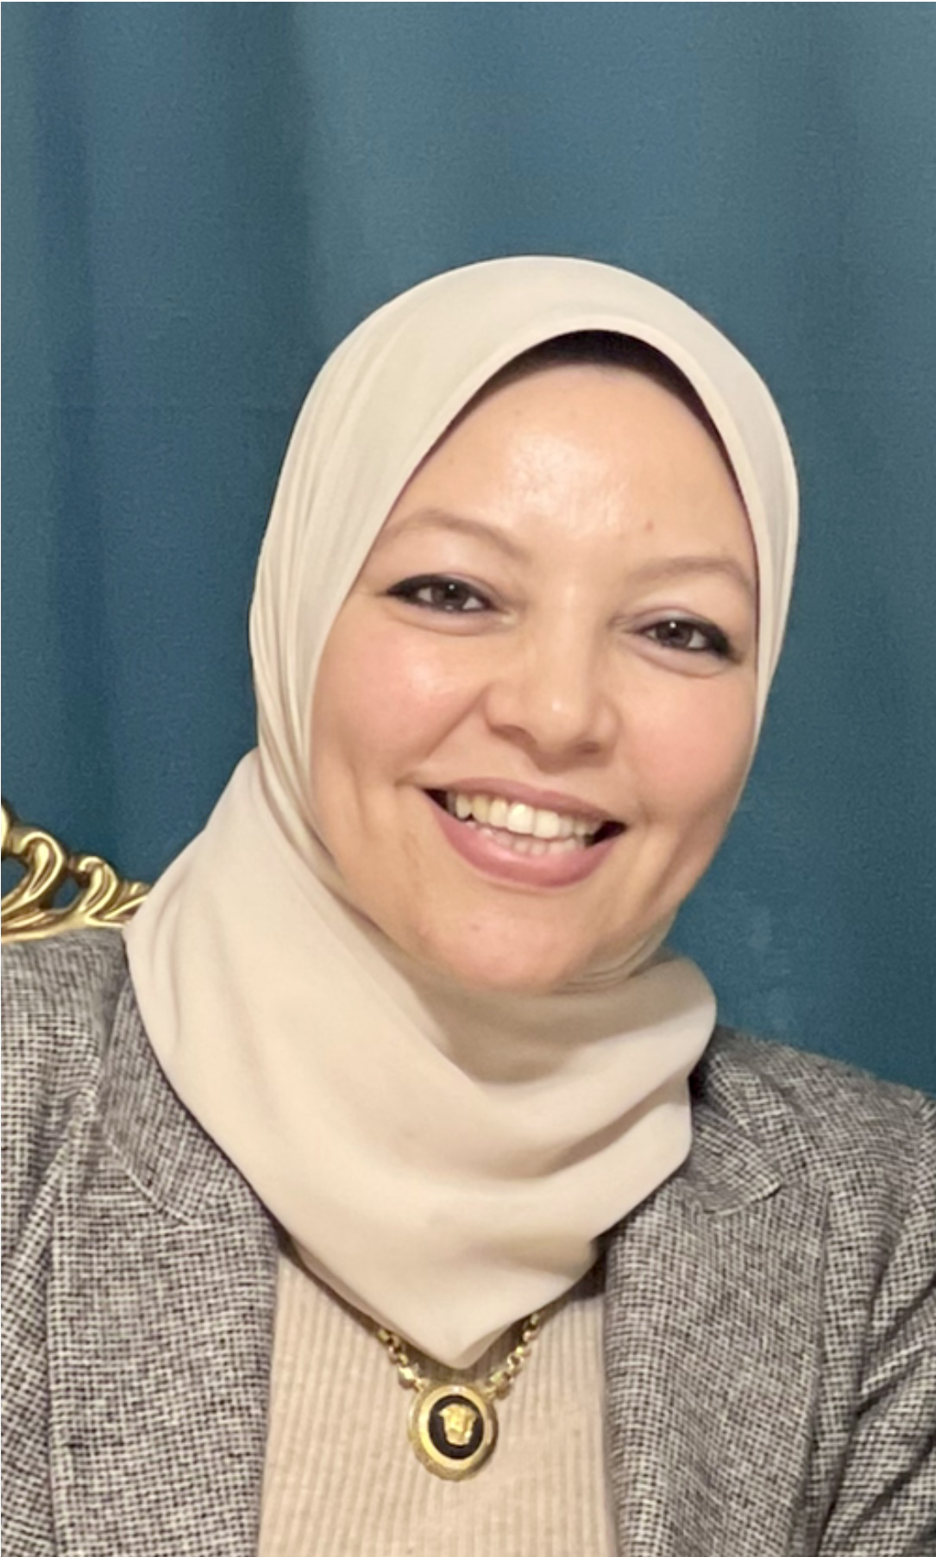
Aml Tarek Ahmed Shatia
Lecture of Psychiatry
Faculty of Medicine, Benha University, Egypt
Mob: (+2)01229547979
E-mail: aml.tarek.shatia@gmail.com

Personal Information
First name: Aml
Middle name: Tarek
Last name: Ahmed Shatia
Nationality: Egyptian
Gender: Female
Marital status: married, has 2 children (male; 8 years and female; 5 years old)
Profession of spouse: Dentist
Date of birth: June 21 1989
Birth place: Egypt
Religion: Muslim
Phones Mobile: +201229547979
E-mails:
aml.tarek.shatia@gmail.com

aml.shatia@fmed.bu.edu.eg
Addresses:
Hospital: Benha University hospitals-Benha faculty of medicine-Egypt
Home: sirs ellayan-menofia -Egypt.
Qualifications:
MD (PhD) of psychiatry
Aug . 2023
Benha Faculty of Medicine, Egypt.
Total grade: very good.
Master of neuropsychiatry
Jan . 2018
Benha Faculty of Medicine, Egypt.
Total grade: Excellent.
M.B.B.Ch. of medicine and surgery
Dec. 2012
Benha Faculty of Medicine, Egypt.
Total grade: excellent with honor.

Experience:
August 2023 till now: Lecturer of psychiatry in Benha University Hospitals and Benha Faculty of Medicine.
(My duties included clinical training and teaching to undergraduate students attached to the department, psychiatric consultant in Benha university hospitals, clinical rounds in inpatient ward and working in outpatient clinic)
Practicing psychiatry and attending lectures in Benha mental Hospital.
January 2018 till Feb 2022 : Assistant lecturer of Psychiatry in Benha University Hospitals and Benha Faculty of Medicine.
(My duties included clinical training and teaching to undergraduate students attached to the department, psychiatric specialist in Benha university hospitals, clinical rounds in inpatient ward and working in outpatient clinic)
Practicing psychiatry and attending lectures in Benha mental Hospital. September 2017 till January 2018: Demonstrator at Benha University Hospital.
September 2014 till June 2017: Resident at Department of Neuro-psychiatry, Benha university Hospitals and Benha Faculty of Medicine.
(My duties included working in inpatient wards, outpatient clinic and intensive care unit).
March 2013 till March 2014: Medical House-Officer at Benha University Hospital.
-My duties during this job included receiving patients in E.R, assisting surgical procedures in O.R and conducting out patients Clinics with Consultants.
-During my stay I had an opportunity to work as a team member of diversified, enthusiastic and perfect medical team.
-I have been working in Emergency Departments for first aids and life support.
-I have been working in different departments rotating through Internal Medicine, Pediatrics, gynecology and obstetrics, General Surgery, Anesthesiology, Emergency Medicine, Cardiology, Clinical Pathology and Blood Bank departments.

Career summary
Ambitious well educated, well trained psychiatrist, with post graduate certifications.

Teaching Experience:
- Aug 2023 till now :Lecturer of psychiatry ,Neuro-psychiatrydepartment, Faculty of Medicine, Benha University, Egypt. department, Faculty of Medicine, Benha University, Egypt.

- Jan 2018 till Feb 2022: Assistant lecturer of psychiatry ,Neuro-psychiatrydepartment, Faculty of Medicine, Benha University, Egypt. department, Faculty of Medicine, Benha University, Egypt.

Strengths
- Expertise in delivering safe and appropriate medications for patients. Keeping up
to date with the latest treatments, medicines and medical developments.
- Keeping annually updated with newest trends, treatments and medical
developments in Psychiatry.
-Familiarity with the newest management procedures.
-Commendable interpersonal skills (with junior physicians, nurses, techs and other healthcare personnel)
-Outstanding communication skills.
-Attention to details.
-Promptness and discipline.
-Able to deal sympathetically with sensitive circumstances.
-A willingness to accept responsibility.
-Experience of working in a pressurized environment.
-Ability to work long and unsociable hours.

Responsibilities
-Provided counseling, assessing and management of patients in outpatients’ clinic
.(annually near 1500 patients)
-Provided counseling, assessing and management for patients in neuropsychiatry department (number of ward beds- 30). Our department is the only specialized unit in allover Qalyubia government and referral center for cases from other hospitals in the government.

-Provided counseling, assessing and management for patients in stroke unit (number of beds- 12)

Provided counseling, assessing and management for patients in general ICU.-
-Diagnosis and management of different psychiatric emergency conditions.
-Supervision for the performance of junior colleagues.
-Periodically a lot of training courses and medical conferences hold at Neuropsychiarty department for the working medical stuff to enhance and improve their medical skills which reflect on professional performance toward patients.

Skill Set:
Teaching skills.
Electroconvulsive therapy ECT practices. Psychotherapy especially CBT, IPT, Group psychotherapy, family psychotherapy and couples psychotherapy.
Computer skills:
- The ICDL (Word and Excel) and excellent experience in PowerPoint presentation
- Excellent command of internet use.
Language skills:
• Arabic: my native language.
• English: TOFEL local exam .
• I speak and write English comfortably .

Research:
Research for MD degree was essay:
“A Study of the psychiatric profile of females undergoing minor cosmetic procedures ”. Under supervision of Prof. Dr. Victor Samy mikhael, Prof. Dr. Mohamed Mostafa el hammady, Prof. Dr. Eman Mostafa kamel..
Research for master degree was essay:
“Sleep patterns in group of obese females”. Under supervision of PROF.Dr. Mohamed Mostafa el hammady, professor of Psychiatry Benha University.

Courses/conferences/workshops:
- 11th International Congress of Psychiatry Ain Shams University (May,
- 2015)
- 9th Kasr Al-Ainy annual international psychiatry congress (February,2016)
- 10th Kasr Al-Ainy annual international psychiatry congress (February,2017)
- 11^{1st} Kasr Al-Ainy annual international psychiatry congress (February,2018)
- 31st Annual Conference of The Egyptian Psychiatric Association
- 1st Annual psychiatric Congress of Tanta Neuropsychiatry Department
- 6th Annual Armed Forces psychiatry congress (april ,2019)
15 th International Congress of Psychiatry Ain Shams University (September, 2019).

Objectives:
Looking for growing and dynamic position within a professional environment for providing high quality health care services.

